|  |
| --- |
|  |
|  |

***Note:*** *At the time of writing, instructions vary on a Mac from those below.*

**Appendix 3 – PowerPoint Button Layering Functions**

A3

The Interactive

Kiosk Project



***Aim:*** *Use animations to hide and display buttons in PowerPoint.*

Action buttons are used in PowerPoint to make things happen. For example, in a supermarket kiosk, you might use action buttons to locate the fruit and vegetables you are purchasing. There are hundreds of different fruit and veg items, so they are usually grouped into categories. One way they could be categorised is by letters of the alphabet as in the simplified example below.

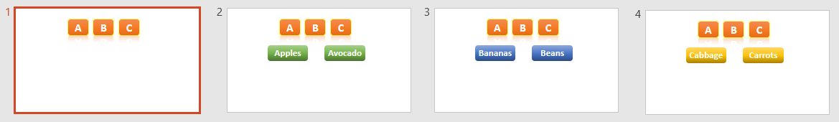

This interface already has 4 slides. If you completed the whole alphabet and also have various kinds of apples and bananas, you could easily end up with hundreds of slides to manage. This isn’t always the best way of doing things. Often, it’s easier in the long run to place lots of objects in a single page and then show and hide them as needed.

#### Task 1 – Showing and Hiding Buttons

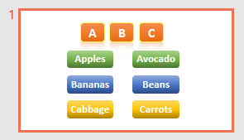You are going to create an interface similar to the one above, but with all the buttons in a single slide.

To start off with, only the buttons named ‘A’, ‘B’ and ‘C’ will be visible. These three buttons will always be on display.

Clicking on the ‘A’ button will make the *Apples* and *Avocado* buttons appear.

Clicking on the ‘B’ button will show the *Bananas* and *Beans* buttons, hiding the *Apples* and *Avocado*.

Clicking on the ‘C’ button will show the *Cabbage* and *Carrots* buttons, also hiding the others. In fact, you should be able to click any letter and display only the relevant two buttons, hiding the other four each time.

1. Start a new blank presentation and delete any textboxes on the first slide. Create the nine buttons as shown.
2. 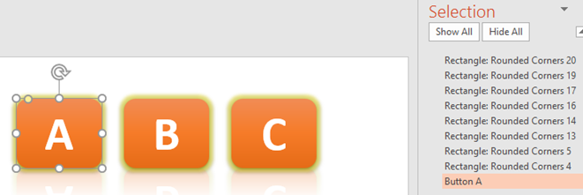Select the ‘A’ button and click ‘Format / Selection Pane’.
3. In the pane that appears on the right, change the name of this button to ‘Button A’.

|  |
| --- |
| **PowerPoint Button Layering (page 2)** |

1. 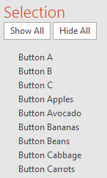Change the name of all the other buttons to something meaningful.

***Extra challenge:*** *Try and do most of this editing job with keyboard shortcuts:*

**Arrow Keys** *Move up and down list*

**F2** *Edit selected item*

**Ctrl + A** *Select all the text in the selected item*

**Ctrl + C** *Copy*

**Ctrl + V** *Paste*

**Enter** *Set new name in place*

1. Once named, you can order the list by dragging items up and down.
2. 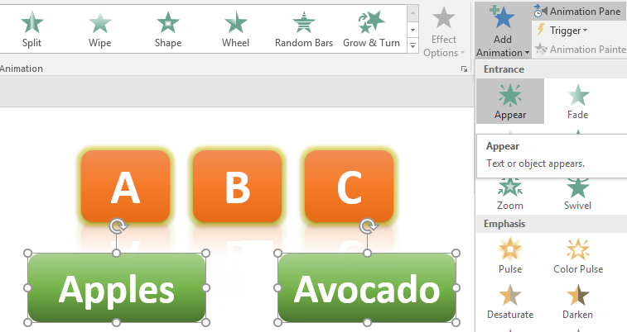Select the *Apples* and *Avocado* buttons together, either by drawing a rectangle around them on screen or by holding down the *Shift* key whilst clicking on each.
3. Select ‘Animations / Add Animation’ and click the green ‘Appear’ option from the *Entrance* effects.

***Note:*** *‘Appear’ is instantaneous. You could select an animation at this point but it will lead to problems. Test this later if you like.*

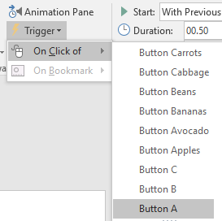

1. Without doing anything else, click ‘Animations / Trigger / On Click of’ and select ‘Button A’ from the list of objects (see right).

1. View the slideshow (remember the ‘F5’ keyboard shortcut will get things started) and check that the two buttons appear when ‘A’ is clicked.
2. With the *Apples* and *Avocado* buttons still selected, add a ‘Disappear’ effect from the red *Exit* animations. Set a trigger so that this occurs when ‘Button B’ is clicked.

1. Repeat the last step, this time setting the trigger to ‘Button C’.
2. 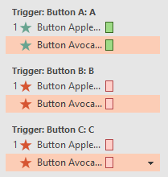Click ‘Animations / Animation Pane’. The list of animations in the pane that opens should look like that shown on the right. If not, then ‘Undo’ and try again.
3. View your presentation, clicking the ‘A’, ‘B’ and ‘C’ buttons repeatedly. You should find that the Apples and Avocados buttons appear when ‘A’ is clicked and disappear when ‘B’ or ‘C’ is clicked.
4. Repeat the process above, setting *Appear* and *Disappear* animations for the *Bananas*, *Beans*, *Cabbage* and *Carrots* buttons. View your presentation. You will probably find that it doesn’t do what you want. Read on.

|  |
| --- |
| **PowerPoint Button Layering (page 3)** |

1. 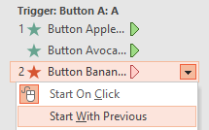In the *Animations Pane*, click on the arrows alongside a few of the animations. You will probably find a mixture of ‘Start On Click’ and ‘Start With Previous’. We need them all to be ‘Start With Previous’ so that they are only controlled by the button actions.

***Tip:*** *Use ‘Ctrl + A’ to select all the animations together and change all the settings in one go.*

1. View your presentation again. The buttons should be better behaved, although some may be visible at the start when you want them to be hidden. This is really a bug in PowerPoint which we’ll work around.  
     
   *If you have unwanted buttons showing up at the start, select all 6 fruit and veg buttons together and add a ‘Disappear’ effect. In the animations pane, change all of these to ‘Start With Previous’. They should now be hidden when you start the presentation.*

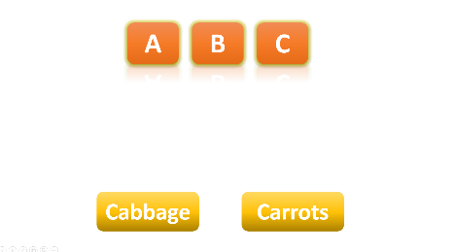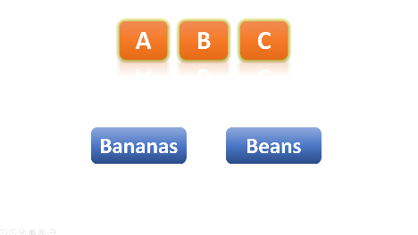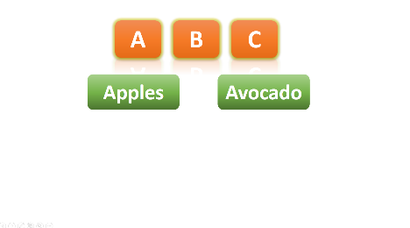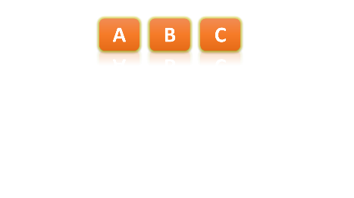

1. Once your buttons are all working as expected, you can actually stack them on top of each other so that they appear in the same place on the screen.

#### Task 2 – Return to Start Prompt

Use action buttons and advanced animation to check whether the user wants to return to the start of the interface.

* A button on Slide 1 should take the user to Slide 2. This will display only a *Return to Start* button.
* Clicking this button will hide it, and display both a button saying ‘Are You Sure?’ and a *Cancel* button.
* Clicking the *Are You Sure?* button will produce a second check, whilst leaving the *Cancel* button in place.
* After one last check button, the user is taken back to Slide 1.
* Clicking the *Cancel* button at any point will display the *Return to Start* button and hide all the others, including itself.

You could incorporate this idea into your kiosk interface.